DIGITAL MARKETING ANALYTICS
USING IBM COGNOS ANALYTICS
A
PROJECT REPORT
SUBMITTED BY
ABHISHEK KUMAR GUPTA
ROLL NO: 25050020001
MASTER OF BUSINESS ADMINISTRATION

SESSION 2026–2027
UNDER THE GUIDANCE OF
MR. FERHAN AHMED
IBM Trainer
United University, Prayagraj Uttar Pradesh, India DESCRIPTIVE ANALYTICS

ACKNOWLEDGEMENT
I express my sincere gratitude to United University, Prayagraj, for providing the academic opportunity to complete this project, “Digital Marketing Analytics Using IBM Cognos Analytics,” as part of the MBA programme for the session 2026–2027.
I am thankful to my IBM Trainer, Mr. Ferhan Ahmed, for his guidance and practical instruction during the project. His support helped me understand how marketing data can be organized, evaluated and communicated through business intelligence dashboards.
I also acknowledge the Faculty of Commerce and Management for the learning environment and academic support that contributed to this work. The concepts studied during the MBA programme helped me connect marketing strategy with measurable campaign outcomes.
This project strengthened my understanding of campaign metrics, data preparation, descriptive analysis and dashboard design. I am grateful to my teachers, classmates and family members for their encouragement throughout the project.
ABHISHEK KUMAR GUPTA
MBA – MARKETING | UNITED UNIVERSITY

ABSTRACT
This project, titled “Digital Marketing Analytics Using IBM Cognos Analytics,” examines the performance of digital marketing campaigns through descriptive analytics and dashboard visualization. A synthetic academic dataset of 300 campaign records was prepared to demonstrate the analysis of reach, engagement, lead generation, conversions, expenditure and revenue.
Microsoft Excel was used to structure the dataset, while IBM Cognos Analytics is identified as the business intelligence platform for importing data, creating visualizations and assembling a performance dashboard. The analysis compares marketing channels, campaign objectives, regions, devices and monthly results.
The sample dataset records 14,580,561 impressions, 506,995 clicks, 43,057 leads and 29,720 conversions. Total campaign spend is ₹1,318,440.29, while attributed revenue is ₹32,974,028.29, producing an overall return on ad spend (ROAS) of 25.01x. These are illustrative values generated for this academic report and are not company-reported results.
The project demonstrates how marketing analytics can make campaign outcomes easier to monitor, support comparisons between channels and help managers identify opportunities for optimization.
Keywords: Digital Marketing, Marketing Analytics, IBM Cognos Analytics, Campaign Performance, CTR, Conversion Rate, ROAS, Dashboard, Business Intelligence.

TABLE OF CONTENTS
- 1. Introduction
- 2. Objectives of the Project
- 3. Problem Statement
- 4. Data Discussion
- 5. Method, Tools and Technologies Used
- 6. Project Workflow
- 7. Results and Dashboard Analysis
- 8. Insights and Observations
- 9. Recommendations and Suggestions
- 10. Conclusion
- References
- Appendix: Sample Dataset

INTRODUCTION

Introduction
Digital marketing has become a central part of business communication and customer acquisition. Organizations use search engines, social networks, email, display advertising and influencer partnerships to reach audiences and promote products or services. Each digital interaction generates measurable information, including impressions, clicks, enquiries, leads, conversions and revenue.
The availability of campaign data creates an opportunity to evaluate marketing activity more systematically. Instead of relying only on reach or engagement, businesses can compare expenditure with meaningful outcomes and understand which channels contribute to lead generation and sales.
Business intelligence platforms help convert operational data into accessible reports and dashboards. IBM Cognos Analytics supports data exploration, reporting and visualization, allowing users to monitor key metrics and communicate performance trends.

Background of the Study
Digital campaigns operate across multiple channels and audiences. Their performance can vary by campaign objective, location, device and time period. Marketing analytics brings these dimensions together and supports evidence-based evaluation of campaign effectiveness.
This project applies descriptive analytics to a synthetic dataset containing 300 campaign-level observations dated across 2025. The records include media spend, impressions, clicks, leads, conversions and attributed revenue. The data is designed for classroom demonstration and does not represent a real organization's confidential campaign results.

Importance of the Study
- Campaign measurement: summarizes reach, engagement and conversion outcomes.
- Channel comparison: evaluates the relative contribution of social, search, email, display and influencer activity.
- Budget monitoring: compares campaign expenditure with generated outcomes.
- Audience understanding: examines regional and device-level response patterns.
- Performance communication: presents results through charts and KPI cards.
- Decision support: demonstrates how structured metrics can inform campaign planning.

Overview of the Project
The project follows a sequence of dataset preparation, data import, field selection, metric calculation, visualization and interpretation. The dashboard is designed around five principal indicators—impressions, clicks, leads, conversions and ROAS—and supporting views of channel, region, campaign objective, device and monthly performance.
- Revenue by marketing channel
- Monthly campaign revenue
- Conversions by marketing channel
- Revenue and conversions by region
- Performance by campaign objective
- Clicks by device

- Marketing expenditure by channel
- Leads by region

Scope of the Study
The study is limited to descriptive analysis of the synthetic dataset. It examines the distribution and relationship of campaign metrics but does not establish causal impact, perform statistical significance testing or forecast future campaign results. Revenue attribution is treated as supplied in the sample data.

Structure of the Report
The report is arranged into ten chapters covering the study background, objectives, problem definition, dataset, methodology, workflow, dashboard results, observations, recommendations and conclusion. References and a sample-data appendix are included at the end.

OBJECTIVES OF THE PROJECT

Introduction
The objectives define the analytical direction of the project and identify the marketing indicators to be summarized through IBM Cognos Analytics.

Primary Objective
To evaluate digital marketing campaign performance using descriptive analytics and develop a dashboard that communicates reach, engagement, lead generation, conversions, expenditure and attributed revenue.

Specific Objectives
- To measure campaign reach through total impressions.
- To assess audience engagement using clicks and click-through rate (CTR).
- To compare the performance of social media, search advertising, email, display advertising and influencer campaigns.
- To examine lead and conversion generation across channels and campaign objectives.
- To compare campaign outcomes across geographical regions.
- To review device-level interaction patterns.
- To summarize campaign expenditure and attributed revenue.
- To calculate key indicators such as CTR, conversion rate, cost per click, cost per lead and ROAS.
- To develop a consolidated dashboard using suitable visualizations.
- To derive practical recommendations for campaign monitoring and optimization.

Expected Outcomes
- A structured digital marketing dataset for analysis.
- A dashboard with clear KPI summaries.
- Comparisons of channel, regional and campaign-objective performance.
- Monthly revenue and campaign activity views.
- A set of evidence-based observations and practical recommendations.
- Improved familiarity with business intelligence and marketing measurement.

Summary
The project aims to demonstrate how digital marketing data can be converted into concise performance information. The selected objectives connect marketing activity with measurable business outcomes.

PROBLEM STATEMENT
Digital marketing teams often manage campaigns across several platforms, each producing different measures and reports. When the information remains separated, it can be difficult to compare channel performance, understand the cost of acquiring leads, or determine whether campaign expenditure is generating revenue.
A high number of impressions does not necessarily indicate strong commercial performance. Similarly, clicks may not translate into qualified leads or completed conversions. Managers therefore need a consistent view of the complete campaign journey, from exposure and engagement to conversion and revenue.

Key Problems Addressed
- Fragmented campaign information across digital channels.
- Difficulty comparing engagement and conversion outcomes.
- Limited visibility into cost efficiency and return on advertising spend.
- Need to identify regional and device-level differences.
- Difficulty tracking campaign performance over time.
- Need for a concise dashboard that supports regular review.

Proposed Solution
The project organizes campaign data in a consistent tabular structure and uses descriptive measures to summarize performance. IBM Cognos Analytics is used as the intended BI environment for visual exploration and dashboard development. KPI cards and comparative charts provide a single view of the selected metrics.
The dataset is synthetic and intended for learning. Accordingly, the results illustrate an analytical approach rather than proving the effectiveness of any real campaign.

DATA DISCUSSION

Dataset Overview
The working dataset contains 300 records representing digital marketing campaign observations across the period January to December 2025. Each record includes a date, campaign objective, channel, region, device, budget, impressions, clicks, spend, leads, conversions and attributed revenue.

Data Source
The dataset was generated synthetically for this academic exercise. It is not downloaded from an advertising account and does not represent verified business transactions. Microsoft Excel can be used to store and review the data before importing it into IBM Cognos Analytics.

Variable Description

Field | Description
Record_ID | Unique identifier for each observation
Date | Campaign reporting date
Campaign_Type | Primary campaign objective
Marketing_Channel | Digital channel used
Region | Broad geographical segment
Device | Device category associated with activity
Budget_INR | Planned budget in Indian rupees
Impressions | Number of ad/content displays
Clicks | Recorded clicks
Spend_INR | Campaign expenditure in rupees
Leads | Enquiries or captured prospects
Conversions | Completed target actions
Revenue_INR | Illustrative revenue attributed to the campaign
CTR_pct | Clicks divided by impressions × 100
Conversion_Rate_pct | Conversions divided by clicks × 100
ROAS | Revenue divided by advertising spend

Nature of the Data
The dataset includes numerical measures, categorical dimensions and date fields. Numerical measures include impressions, clicks, budget, spend, leads, conversions and revenue. Categorical dimensions include channel, campaign objective, region and device. The date field supports time-based aggregation.

Data Preparation
- Organize each campaign observation as one row.
- Use consistent field names and data types.
- Check that numeric fields contain valid non-negative values.

- Review missing or duplicate records before analysis.
- Calculate CTR, conversion rate and ROAS using consistent formulas.
- Import the prepared workbook into the BI environment.
- Select suitable aggregations for each chart and KPI.

Analytical Scope
- Channel-wise revenue, spend, clicks and conversions.
- Monthly revenue movement.
- Regional leads, conversions and revenue.
- Campaign-objective comparison.
- Device contribution to clicks.
- Overall campaign KPIs.

Dataset Limitations
The data is simulated, contains a limited number of records and uses simplified channel and regional categories. Revenue attribution is illustrative. The analysis does not account for view-through attribution, organic effects, audience overlap, seasonality controls or external market factors. Findings should therefore be interpreted as a demonstration.

Summary
The dataset provides a structured example of campaign performance data. Its fields support the calculation of engagement, acquisition and return metrics, allowing a practical demonstration of dashboard design.

METHOD, TOOLS AND TECHNOLOGIES USED

Research Methodology
A descriptive analytical approach is used to summarize campaign activity and compare performance across dimensions. The process includes data preparation, metric calculation, aggregation, visualization and interpretation.

Tools Used

Microsoft Excel
Microsoft Excel is used for tabular data storage, basic validation, formula-based calculations and preparation of the dataset for analysis.

IBM Cognos Analytics
IBM Cognos Analytics is the selected business intelligence platform for importing the prepared dataset, exploring fields, building charts and arranging visual components into a dashboard. The report's dashboard visuals are illustrative outputs prepared from the sample data; they should be recreated or validated in the user's Cognos workspace before claiming they were exported directly from Cognos.

Metrics and Formulas

Metric | Formula / Meaning
CTR | Clicks ÷ Impressions × 100
Conversion Rate | Conversions ÷ Clicks × 100
Cost per Click (CPC) | Spend ÷ Clicks
Cost per Lead (CPL) | Spend ÷ Leads
Return on Ad Spend (ROAS) | Attributed Revenue ÷ Spend
Lead-to-Conversion Rate | Conversions ÷ Leads × 100

Analytical Techniques
- Descriptive statistics: totals, counts, averages and ratios.
- Grouping: summarize metrics by channel, region, campaign objective and device.
- Trend analysis: compare monthly campaign revenue.
- Data visualization: use bar, line and pie charts to communicate patterns.
- KPI monitoring: display selected metrics as dashboard cards.

Summary
Excel and IBM Cognos Analytics provide a practical workflow for preparing, analyzing and communicating campaign information. The project emphasizes clear metric definitions and consistent aggregation.

PROJECT WORKFLOW
- Dataset creation: generate a structured sample of campaign observations.
- Data understanding: review dimensions, measures and reporting period.
- Data preparation: validate fields and calculate derived metrics.
- Data import: load the prepared file into IBM Cognos Analytics.
- Variable selection: choose dimensions and measures for each analysis.
- Visualization: create charts for channel, region, device, objective and time.
- KPI setup: display impressions, clicks, leads, conversions and ROAS.
- Dashboard assembly: arrange visualizations into a single reporting view.
- Review: verify formulas, labels, filters and aggregation settings.
- Documentation: record the method, outputs, observations and limitations.

Workflow Diagram
Sample Dataset (Excel) ↓ Data Validation ↓ Metric Calculation ↓ Import into IBM Cognos Analytics ↓ Chart Development ↓ KPI Cards ↓ Dashboard Review ↓ Interpretation and Report

Summary
The workflow provides a repeatable sequence from raw campaign records to a summarized dashboard. Validation of formulas and aggregation settings is important to ensure that the displayed indicators are meaningful.

RESULTS AND DASHBOARD ANALYSIS
This chapter summarizes the synthetic campaign dataset and presents dashboard-style visualizations generated from the sample records. All monetary figures are expressed in Indian rupees.

Overall KPI Summary

Indicator | Illustrative Result
Campaign records | 300
Total impressions | 14,580,561
Total clicks | 506,995
Overall CTR | 3.48%
Total leads | 43,057
Total conversions | 29,720
Total spend | ₹1,318,440.29
Attributed revenue | ₹32,974,028.29
Conversion rate | 5.86%
Average CPC | ₹2.60
Cost per lead | ₹30.62
ROAS | 25.01x

Dashboard Overview
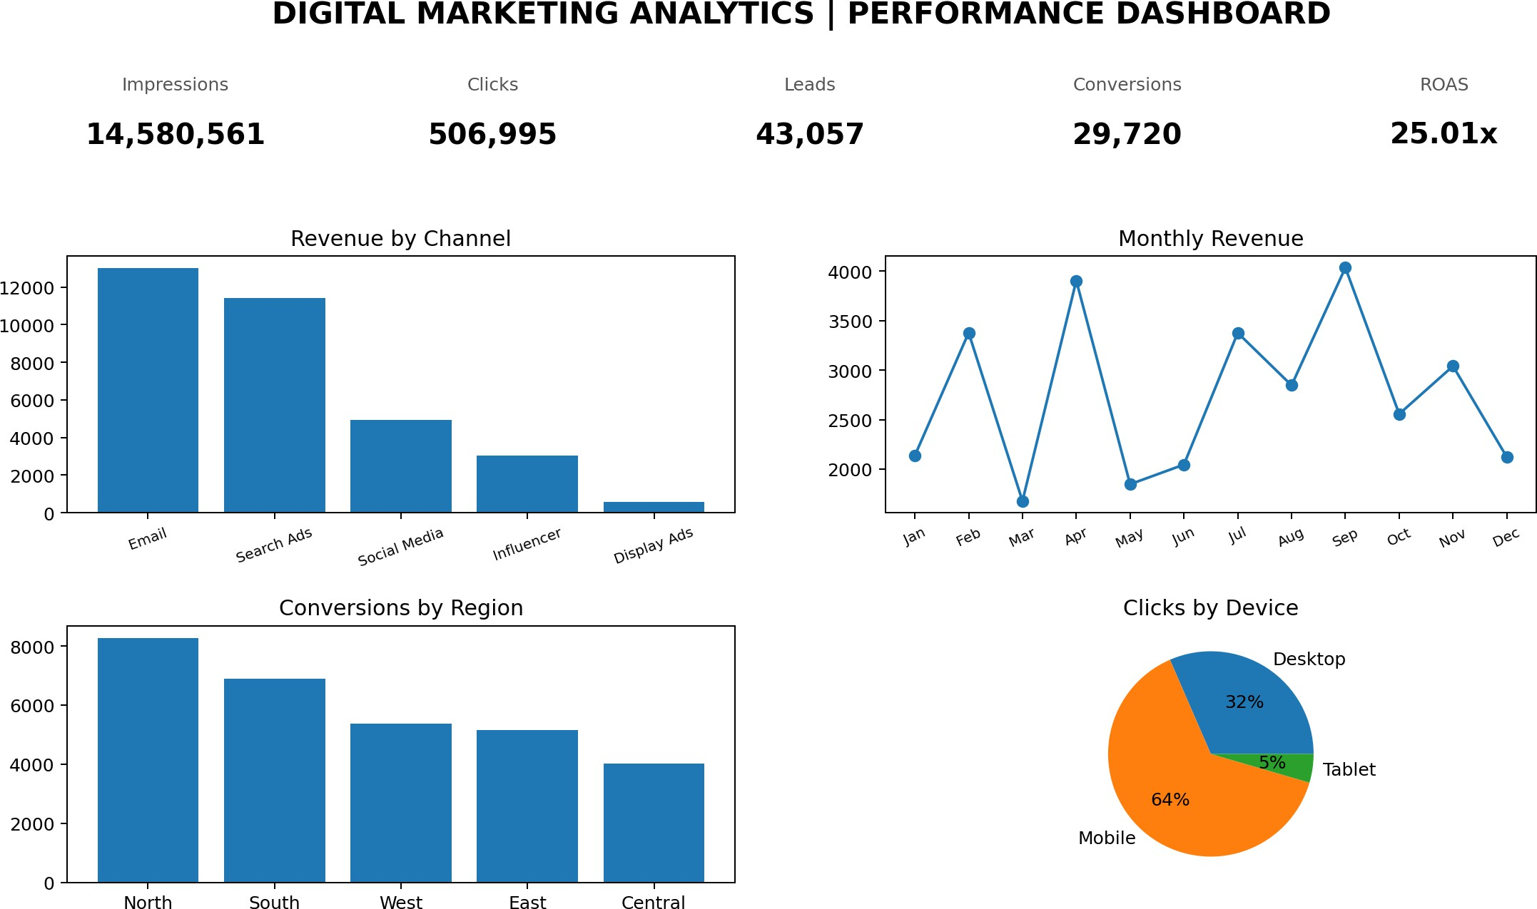
Figure 7.1: Digital marketing performance dashboard overview

Revenue by Marketing Channel
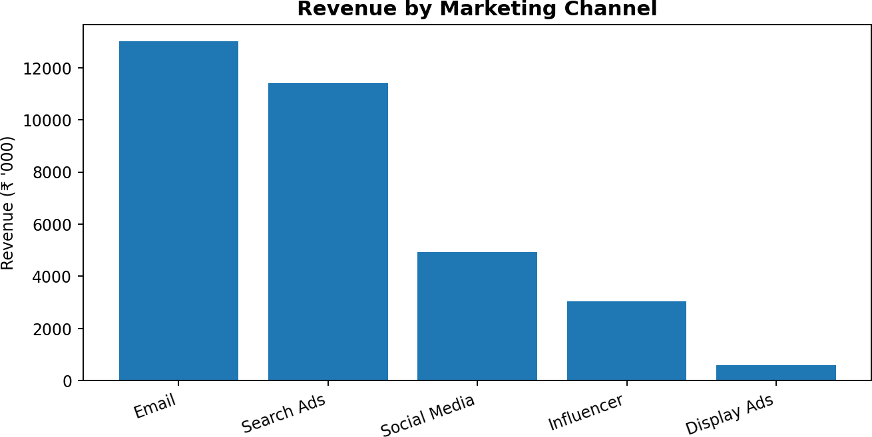

Figure 7.2: Revenue contribution by marketing channel
The chart compares attributed revenue across the five channels. It can be used to identify channels that contribute a larger revenue value in the sample and to guide further investigation of their spend and conversion quality.

Monthly Campaign Revenue
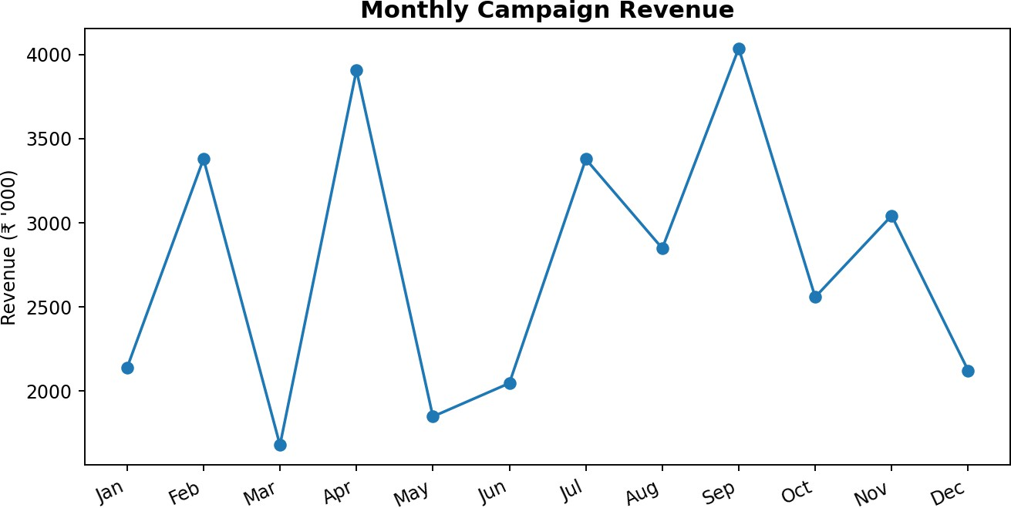
Figure 7.3: Monthly attributed revenue
The monthly view shows how recorded revenue varies through the year. Month-to-month movement should be interpreted alongside campaign budgets, promotional calendars and changes in activity volume.

Conversions by Marketing Channel
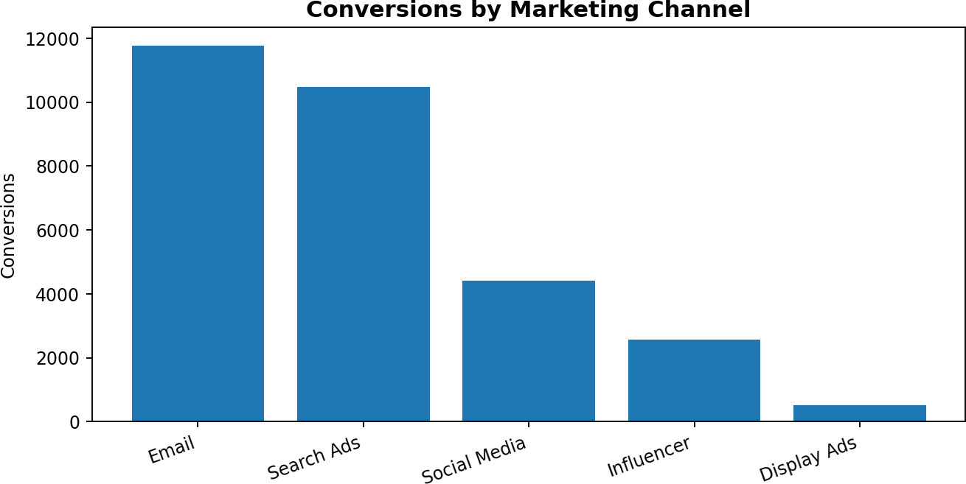

Figure 7.4: Conversions by marketing channel
This comparison focuses on completed target actions rather than exposure alone. A channel with more conversions should also be reviewed for spend efficiency and the quality of the resulting customers.

Revenue by Region
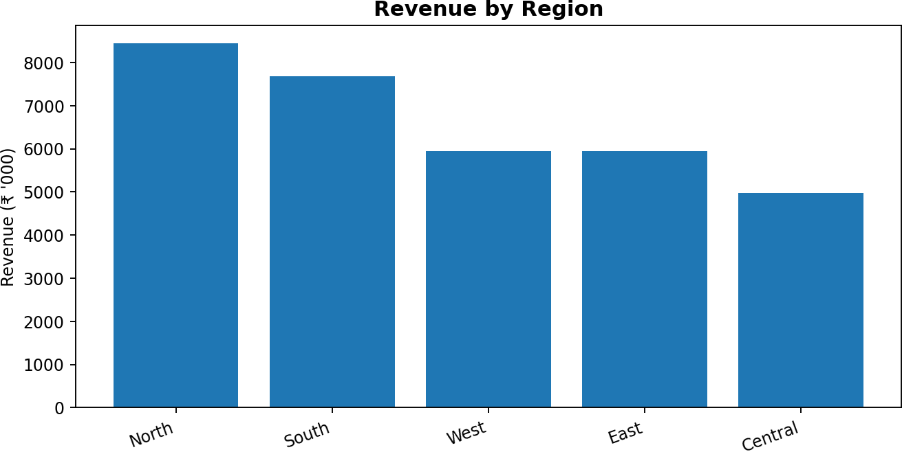
Figure 7.5: Revenue by region
Regional aggregation helps compare the revenue associated with the broad geographical segments in the sample. It can inform where additional audience research or localized messaging may be useful.

Campaign Objective Analysis
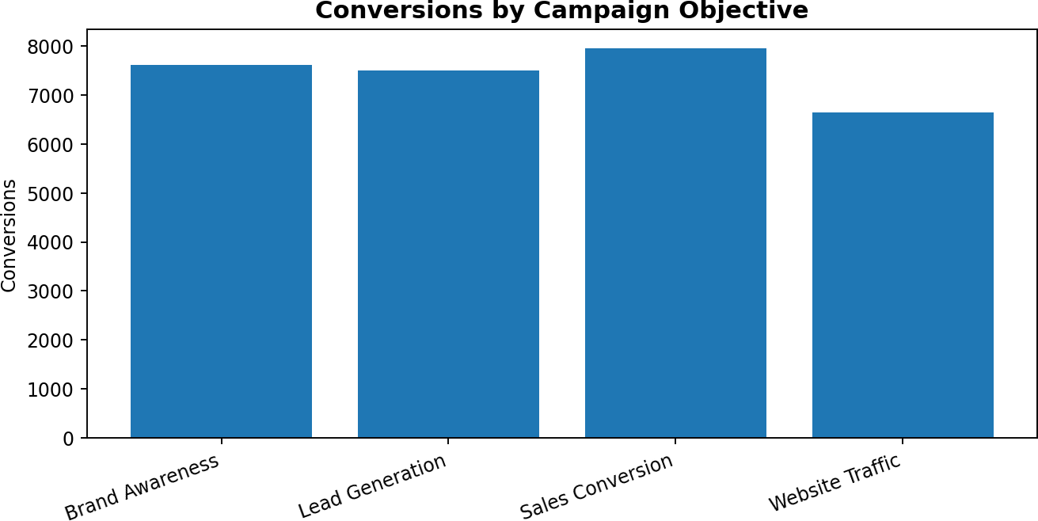
Figure 7.6: Conversions by campaign objective
The chart compares conversions across brand awareness, lead generation, website traffic and sales conversion objectives. The objective definitions should remain consistent when comparing campaigns.

Device-Level Click Activity
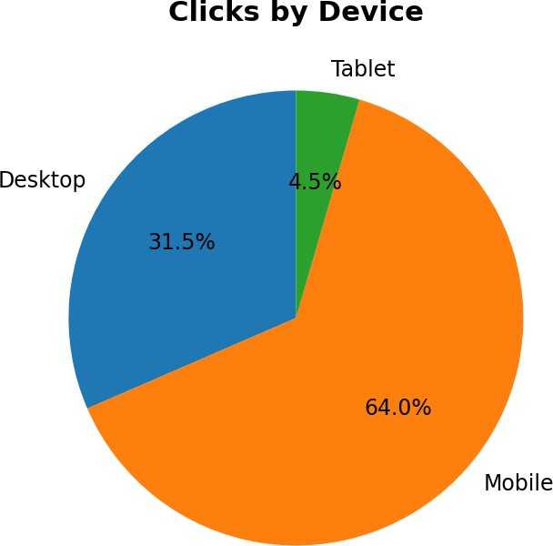

Figure 7.7: Share of clicks by device
Device-level analysis provides a view of how clicks are distributed between mobile, desktop and tablet. This can guide landing-page testing and user-experience improvements.

Marketing Spend by Channel
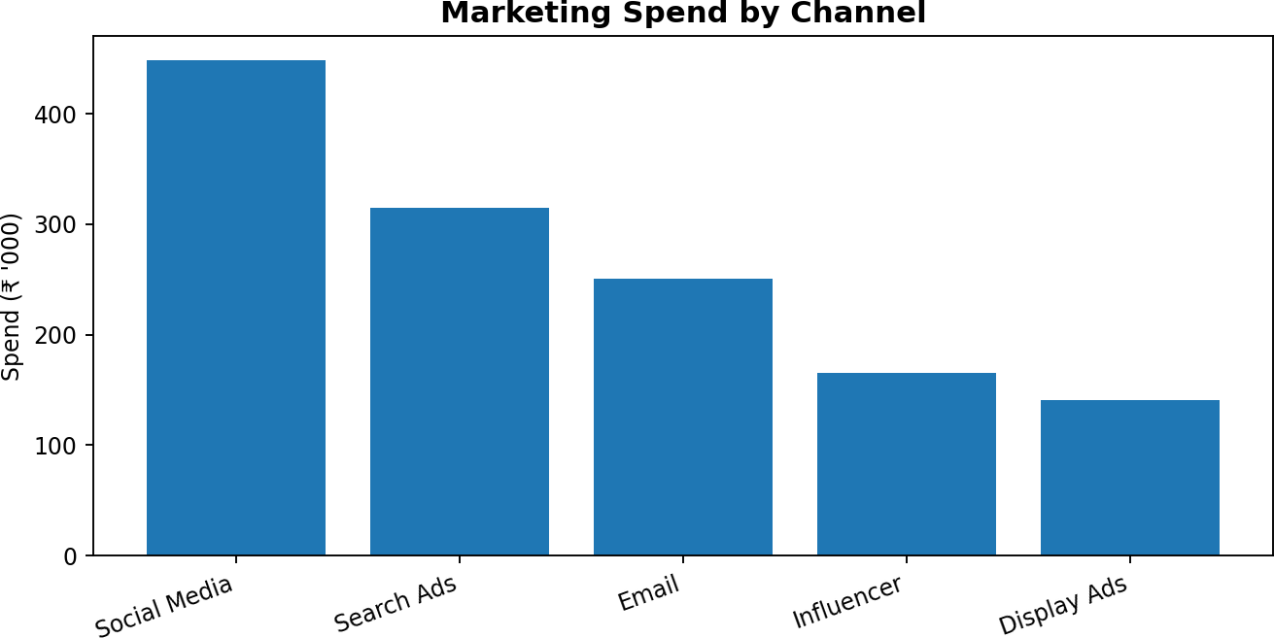

Figure 7.8: Marketing expenditure by channel
Comparing spend with revenue and conversions helps avoid evaluating channels on volume alone. Budget decisions should consider both outcome and efficiency metrics.

Leads by Region
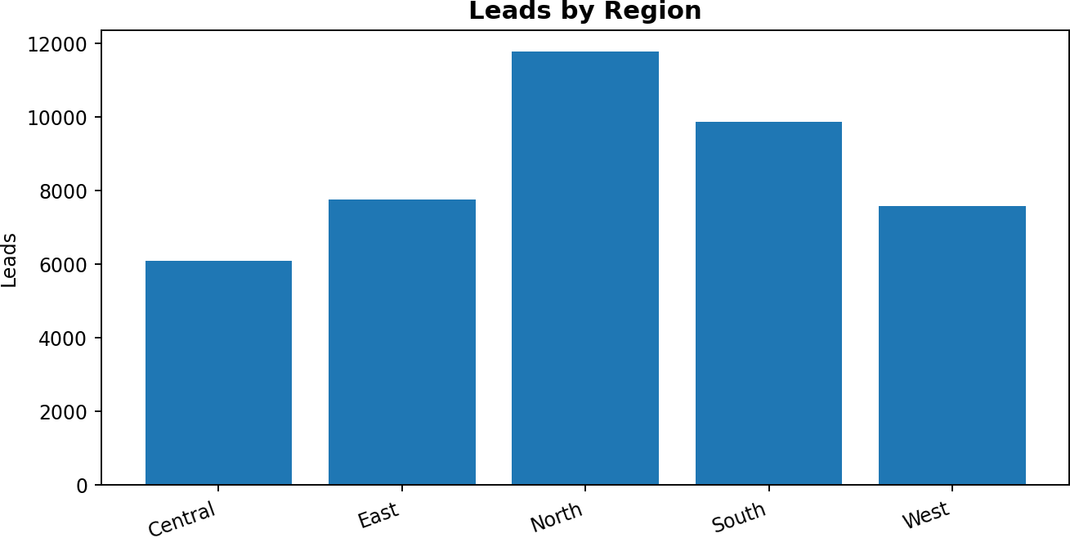
Figure 7.9: Leads by region
Lead distribution indicates where the sample campaigns captured prospect interest. Lead quality and subsequent conversion should be assessed before drawing conclusions about regional value.

Summary of Results
The sample records contain 14,580,561 impressions and 506,995 clicks, with an overall CTR of 3.48%. They record 43,057 leads and 29,720 conversions. Total expenditure is ₹1,318,440.29, and illustrative attributed revenue is ₹32,974,028.29, giving a ROAS of 25.01x.

INSIGHTS AND OBSERVATIONS

Reach and Engagement
The dataset records 14,580,561 impressions and 506,995 clicks, resulting in an overall CTR of 3.48%. CTR offers a normalized view of click response relative to impressions, although it does not measure conversion quality on its own.

Lead and Conversion Activity
A total of 43,057 leads and 29,720 conversions are recorded. The overall click-to-conversion rate is 5.86%. The difference between leads and conversions highlights why the full funnel should be monitored.

Channel Performance
In the generated sample, Email ranks first by attributed revenue. This is a descriptive result from the simulated data and should not be treated as a universal benchmark. Channel performance should be evaluated alongside spend, audience fit and lead quality.

Monthly Performance
The highest recorded monthly revenue in this sample occurs in Sep. Monthly comparisons can help identify periods for deeper review, but they do not establish the reason for the observed change.

Regional Performance
North is the leading region by attributed revenue in the sample. Regional differences may reflect the distribution of campaign activity and should be examined with spend and conversion data.

Campaign Objective
Different campaign objectives are designed to achieve different outcomes. Awareness activity should be assessed using reach and engagement measures, while lead-generation and sales campaigns should be reviewed using qualified leads, conversions and cost efficiency.

Device Usage
The device chart shows the share of clicks across mobile, desktop and tablet. A high click share on a device makes responsive landing pages and a frictionless conversion journey especially important.

Efficiency Measures
The sample produces an average CPC of ₹2.60, a cost per lead of ₹30.62 and ROAS of 25.01x. These indicators are useful for comparing campaigns, provided that spend and revenue are attributed consistently.

Summary of Observations
The dashboard brings reach, engagement, lead generation, conversions and revenue into one reporting view. The most useful interpretation comes from reviewing multiple indicators together rather than treating a single metric as proof of campaign success.

RECOMMENDATIONS AND SUGGESTIONS

Optimize Channel Mix
Review channel performance using revenue, conversions, CPC and ROAS together. Allocate additional budget only after validating performance over a sufficient period.

Improve Creative Engagement
Test alternative headlines, visuals, calls to action and audience segments. Monitor CTR while ensuring that higher engagement also contributes to relevant traffic.

Strengthen Landing Pages
Keep landing-page messaging consistent with the advertisement, reduce unnecessary form fields and improve page speed across devices.

Improve Lead Quality
Use clear qualification criteria and review lead-to-conversion outcomes. Coordinate marketing and sales teams to identify which lead sources create genuine opportunities.

Monitor Cost Efficiency
Track CPC, CPL and ROAS by campaign and channel. Investigate sudden changes before making major budget adjustments.

Localize Regional Campaigns
Use regional performance as a starting point for audience research. Adapt language, offers and creative material to relevant customer needs.

Adopt Device-Specific Testing
Review the mobile and desktop user journey separately. Test navigation, forms, page loading and checkout steps on common screen sizes.

Maintain Measurement Quality
Use consistent campaign naming, tracking parameters and conversion definitions. Check for missing data, duplicate events and inconsistent attribution.

Build a Regular Reporting Cycle
Review key indicators weekly or monthly depending on campaign duration. Compare current results with prior periods and documented campaign objectives.

Use Dashboards for Decisions
Use the dashboard to identify questions requiring investigation, not as a substitute for business context. Record actions taken and assess their outcomes in subsequent reporting.

Summary
The recommendations emphasize balanced measurement, disciplined budget allocation, improved user experience and reliable tracking. Continuous monitoring can help marketing teams learn from campaign outcomes and improve future activity.

CONCLUSION
The project, “Digital Marketing Analytics Using IBM Cognos Analytics,” demonstrates how campaign information can be organized and interpreted through descriptive analytics. The study uses a synthetic dataset of 300 records to review impressions, clicks, leads, conversions, expenditure and attributed revenue across multiple marketing dimensions.
The illustrative analysis records 14,580,561 impressions, 506,995 clicks, 43,057 leads and 29,720 conversions. It records total spend of ₹1,318,440.29 and attributed revenue of ₹32,974,028.29, with a calculated ROAS of 25.01x. These figures are sample outputs created for academic demonstration.
The dashboard-style charts provide comparative views of marketing channels, monthly revenue, regions, campaign objectives and devices. The project also highlights the importance of using consistent metric definitions and evaluating engagement together with conversion and cost measures.
Overall, the exercise provides practical exposure to dataset preparation, marketing measurement, visualization and business intelligence reporting. The results are illustrative and should not be represented as findings from a real organization.

REFERENCES
- IBM. IBM Cognos Analytics Documentation. https://www.ibm.com/docs/en/cognos-analytics
- IBM. IBM Cognos Analytics product information. https://www.ibm.com/products/cognos-analytics
- Microsoft. Excel help and learning resources. https://support.microsoft.com/excel
- Google. Analytics Help: Reports and measurement concepts. https://support.google.com/analytics
- Meta. Business Help Center: Advertising measurement and reporting. https://www.facebook.com/business/ help
- Course materials: MBA programme, United University, Prayagraj.
- Digital Marketing Analytics Sample Dataset: synthetically generated for this academic project.

APPENDIX: SAMPLE DATASET
The accompanying spreadsheet contains the 300 synthetic campaign observations used to calculate the summary metrics and prepare the charts in this report. The sample is for educational use only.

Channel | Spend (₹) | Clicks | Conversions | Revenue (₹)
Email | 250,168 | 132,099 | 11,758 | 13,005,194
Search Ads | 314,467 | 161,043 | 10,485 | 11,414,731
Social Media | 447,807 | 127,282 | 4,408 | 4,930,151
Influencer | 165,341 | 57,838 | 2,565 | 3,033,672
Display Ads | 140,657 | 28,733 | 504 | 590,280
Note: The chart images in this report are newly prepared illustrative dashboard visuals based on the generated sample dataset. They are not screenshots captured from an IBM Cognos Analytics account.

